**Project Design Phase-II**

**Data Flow Diagram & User Stories**

|  |  |
| --- | --- |
| Date | 21 June 2025 |
| Team ID | LTVIP2025TMID49911 |
| Project Name | Cosmetic Insights : Navigating Cosmetics Trends and Consumer Insights with Tableau |
| Maximum  Marks | 4 Marks |

**Data Flow Diagram (Standard flow) :**

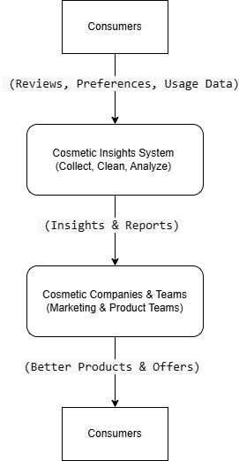

# 1. Consumers Provide Data

* **Data:** Reviews, preferences, and usage information.
* **How:** Through surveys, product reviews, and social media.

# 2. Cosmetic Insights System (Process)

* **Actions:** Collects, cleans, and analyzes data.
* **Tools:** Uses Tableau for creating visualizations and reports.

**3. Output: Insights & Reports**

• **Outcome:** Provides insights and interactive reports for marketing and product teams.

# 4. Cosmetic Companies & Teams Use Insights

* **Teams:** Marketing and product development.
* **Actions:** Use insights to create better products and targeted marketing offers.

**5. Result: Better Products & Offers**

• **Outcome:** Consumers receive improved products and personalized offers.

# 6. Feedback Loop

• Consumers provide more feedback, and the cycle repeats as companies continue to improve based on new data.

# User Stories

|  |  |  |  |  |  |  |
| --- | --- | --- | --- | --- | --- | --- |
| **User Type** | **Functional**  **Requirement**  **(Epic)** | **User**  **Story**  **Number** | **User Story / Task** | **Acceptance**  **criteria** | **Priority** | **Release** |
| Data Analyst | Data Upload | USN-1 | As an analyst, I can upload raw cosmetics datasets into the system. | Data is successfully uploaded and stored for cleaning. | High | Sprint-1 |
|  | Data  Cleaning | USN-2 | As an analyst, I can clean the raw data by removing duplicates and fixing missing values. | Cleaned data is saved and verified. | High | Sprint-1 |
|  | Data Storage | USN-3 | As an analyst, I can store cleaned data securely for analysis. | Data is stored in the central repository. | High | Sprint-1 |
|  | Data  Processing | USN-4 | As an analyst, I can filter, aggregate, and transform data for visual analysis. | Processed data is ready for Tableau dashboards. | High | Sprint-1 |
| Business  Manager | Insights  Dashboard | USN-5 | As a manager, I can view  interactive dashboards showing consumer trends and product rankings. | Dashboard displays key KPIs clearly. | High | Sprint-2 |
|  | Real-Time  Alerts | USN-6 | As a manager, I receive alerts  when consumer preferences drop or product concerns arise. | Alerts are triggered correctly and visible in the dashboard. | Medium | Sprint-3 |
| Product  Development | Product  Analysis | USN-7 | As a product team member, I can analyze product performance and | Insights are shown for each skin | Medium | Sprint-2 |
| **User Type** | **Functional**  **Requirement**  **(Epic)** | **User**  **Story**  **Number** | **User Story / Task** | **Acceptance**  **criteria** | **Priority** | **Release** |
|  |  |  | suitability for different skin types. | type with clear visuals. |  |  |
| Marketing  Team | Export  Reports | USN-8 | As a marketer, I can export insights reports from Tableau dashboards. | Reports are downloadable in PDF or Excel. | Medium | Sprint-3 |